Asia-China-Coin-Wang Mang-H 9.12-Mould-R 3

Wang Mang (7-23 CE) Yi Dao Ping Wu Qian (One knife worth five thousand). Missing the inl;aid gold characters Yi Dao. FD 458, S 119, H 9.12. Mould

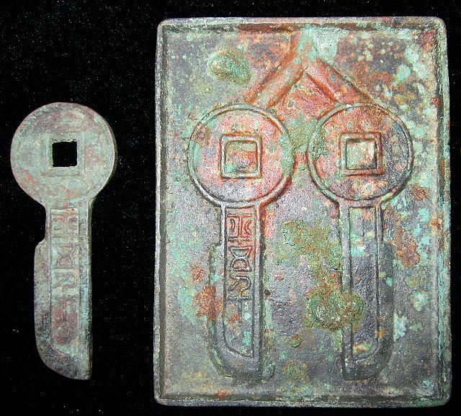

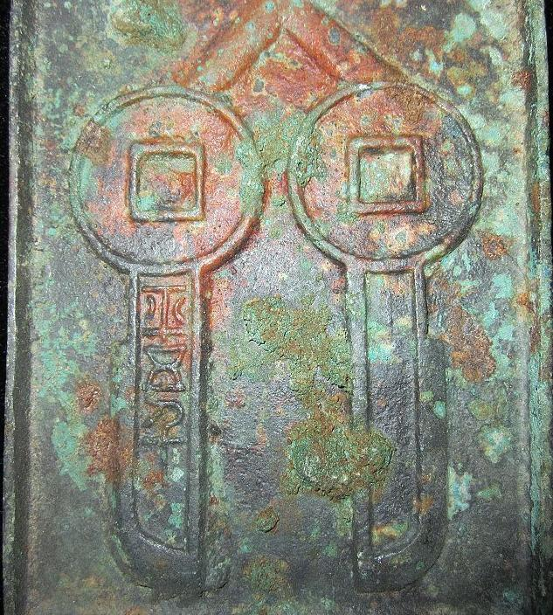 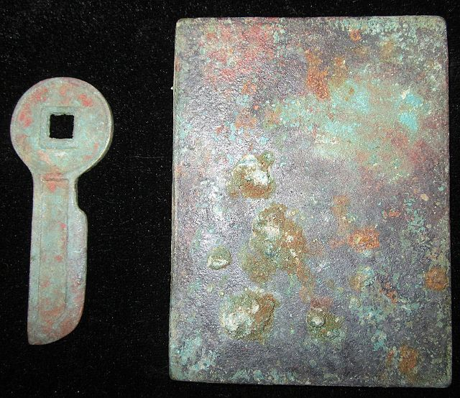

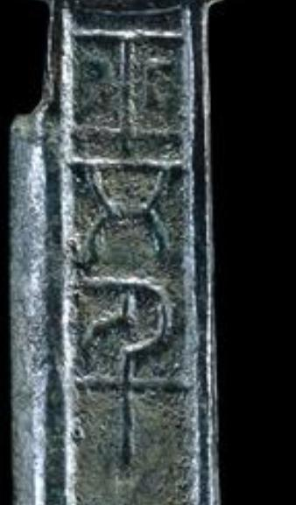

Order details Printer friendly page

Sold by

[bcculture](http://myworld.ebay.com/bcculture) ( [81](http://feedback.ebay.com/ws/eBayISAPI.dll?ViewFeedback&userid=bcculture)  )

+ Show additional actions

Delivery package 1 of 1

Estimated delivery Wednesday, Jan 22, 2014 - Wednesday, Feb 19, 2014

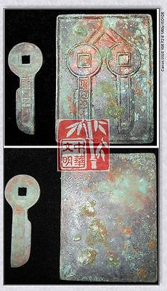

[VINTAGE CHINA HAN XINMANG TIME MONEY MODEL BRONZE FALCHION COIN PATTERN一刀平五千RARE](http://www.ebay.com/itm/251412096330)

Item price

$69.99

Quantity

1

Item number

251412096330

Shipping service

Economy Shipping from outside US

[Leave feedback](http://feedback.ebay.com/ws/eBayISAPI.dll?LeaveFeedbackShow&useridfrom=802-867&useridto=bcculture&item=251412096330&transactid=1360924251015) [Contact seller](http://contact.ebay.com/ws/eBayISAPI.dll?FindAnswers&frm=3998&iid=251412096330&redirect=0&requested=bcculture) [Return item](http://return.ebay.com/ws/eBayISAPI.dll?ResolveReturn&eventName=viewSelectedItem&TransactionId=1360924251015&ItemId=251412096330)

Sold by

[nl2222](http://myworld.ebay.com/nl2222) ( [434](http://feedback.ebay.com/ws/eBayISAPI.dll?ViewFeedback&userid=nl2222)  )

+ Show additional actions

Delivery package 1 of 1

Estimated delivery Friday, Jan 10, 2014 - Saturday, Jan 18, 2014

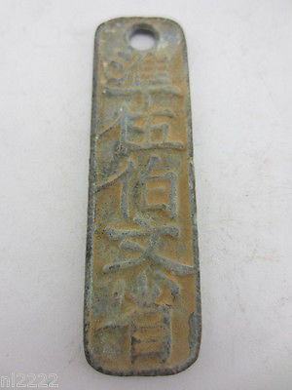

[collection of ancient Chinese bronze pendant carved font lin an fu 23g](http://www.ebay.com/itm/321282265233)

Item price

$0.99

Quantity

1

Item number

321282265233

Shipping service

ePacket delivery from China

[Leave feedback](http://feedback.ebay.com/ws/eBayISAPI.dll?LeaveFeedbackShow&useridfrom=802-867&useridto=nl2222&item=321282265233&transactid=0) [Contact seller](http://contact.ebay.com/ws/eBayISAPI.dll?FindAnswers&frm=3998&iid=321282265233&redirect=0&requested=nl2222) [Return item](http://return.ebay.com/ws/eBayISAPI.dll?ResolveReturn&eventName=viewSelectedItem&TransactionId=0&ItemId=321282265233)

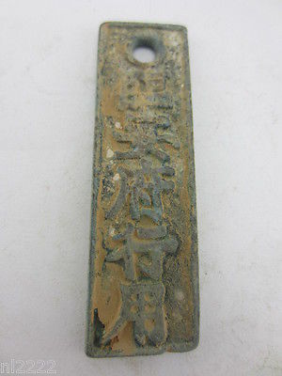

[collection of ancient Chinese bronze pendant carved font lin an fu 21g](http://www.ebay.com/itm/321282265237)

Item price

$3.99

Quantity

1

Item number

321282265237

Shipping service

ePacket delivery from China

[Leave feedback](http://feedback.ebay.com/ws/eBayISAPI.dll?LeaveFeedbackShow&useridfrom=802-867&useridto=nl2222&item=321282265237&transactid=0) [Contact seller](http://contact.ebay.com/ws/eBayISAPI.dll?FindAnswers&frm=3998&iid=321282265237&redirect=0&requested=nl2222) [Return item](http://return.ebay.com/ws/eBayISAPI.dll?ResolveReturn&eventName=viewSelectedItem&TransactionId=0&ItemId=321282265237)

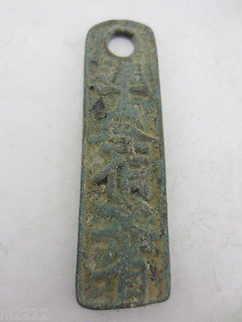

[collection of ancient Chinese bronze pendant carved font lin an fu 20g](http://www.ebay.com/itm/321282265240)

Item price

$3.99

Quantity

1

Item number

321282265240

Shipping service

ePacket delivery from China

[Leave feedback](http://feedback.ebay.com/ws/eBayISAPI.dll?LeaveFeedbackShow&useridfrom=802-867&useridto=nl2222&item=321282265240&transactid=0) [Contact seller](http://contact.ebay.com/ws/eBayISAPI.dll?FindAnswers&frm=3998&iid=321282265240&redirect=0&requested=nl2222) [Return item](http://return.ebay.com/ws/eBayISAPI.dll?ResolveReturn&eventName=viewSelectedItem&TransactionId=0&ItemId=321282265240)

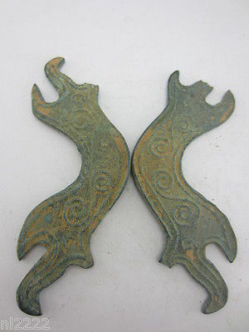

[Ancient Chinese bronze commodity trading tools. Shape of the bridge](http://www.ebay.com/itm/321282265245)

Item price

$0.11

Quantity

1

Item number

321282265245

Shipping service

ePacket delivery from China

[Leave feedback](http://feedback.ebay.com/ws/eBayISAPI.dll?LeaveFeedbackShow&useridfrom=802-867&useridto=nl2222&item=321282265245&transactid=0) [Contact seller](http://contact.ebay.com/ws/eBayISAPI.dll?FindAnswers&frm=3998&iid=321282265245&redirect=0&requested=nl2222) [Return item](http://return.ebay.com/ws/eBayISAPI.dll?ResolveReturn&eventName=viewSelectedItem&TransactionId=0&ItemId=321282265245)

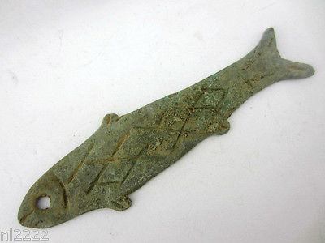

[Ancient Chinese bronze fish pendant. Tools of the trade. Rust](http://www.ebay.com/itm/321283572758)

Item price

$5.99

Quantity

1

Item number

321283572758

Shipping service

ePacket delivery from China

[Leave feedback](http://feedback.ebay.com/ws/eBayISAPI.dll?LeaveFeedbackShow&useridfrom=802-867&useridto=nl2222&item=321283572758&transactid=0) [Contact seller](http://contact.ebay.com/ws/eBayISAPI.dll?FindAnswers&frm=3998&iid=321283572758&redirect=0&requested=nl2222) [Return item](http://return.ebay.com/ws/eBayISAPI.dll?ResolveReturn&eventName=viewSelectedItem&TransactionId=0&ItemId=321283572758)

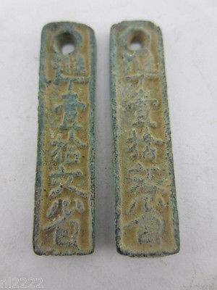

[collection of ancient Chinese bronze pendant carved font lin an fu](http://www.ebay.com/itm/221341938119)

Item price

$0.99

Quantity

1

Item number

221341938119

Shipping service

ePacket delivery from China

[Leave feedback](http://feedback.ebay.com/ws/eBayISAPI.dll?LeaveFeedbackShow&useridfrom=802-867&useridto=nl2222&item=221341938119&transactid=0) [Contact seller](http://contact.ebay.com/ws/eBayISAPI.dll?FindAnswers&frm=3998&iid=221341938119&redirect=0&requested=nl2222) [Return item](http://return.ebay.com/ws/eBayISAPI.dll?ResolveReturn&eventName=viewSelectedItem&TransactionId=0&ItemId=221341938119)

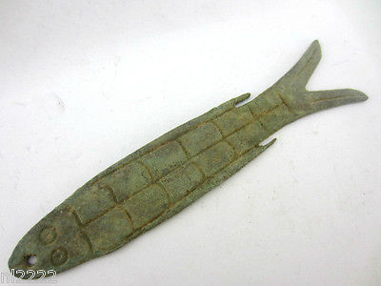

[Ancient Chinese bronze pendant. Tools trade. sculpture fish. Decorative pattern](http://www.ebay.com/itm/221342725842)

Item price

$5.99

Quantity

1

Item number

221342725842

Shipping service

ePacket delivery from China

[Leave feedback](http://feedback.ebay.com/ws/eBayISAPI.dll?LeaveFeedbackShow&useridfrom=802-867&useridto=nl2222&item=221342725842&transactid=0) [Contact seller](http://contact.ebay.com/ws/eBayISAPI.dll?FindAnswers&frm=3998&iid=221342725842&redirect=0&requested=nl2222) [Return item](http://return.ebay.com/ws/eBayISAPI.dll?ResolveReturn&eventName=viewSelectedItem&TransactionId=0&ItemId=221342725842)

Sold by

[lengxue](http://myworld.ebay.com/lengxue) ( [28](http://feedback.ebay.com/ws/eBayISAPI.dll?ViewFeedback&userid=lengxue)  )

+ Show additional actions

Delivery package 1 of 1

Estimated delivery Friday, Jan 10, 2014 - Saturday, Jan 18, 2014

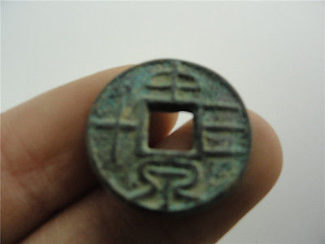

[China Tools of the trade, wangmang period, bronze sculptures,zhongquansanshi](http://www.ebay.com/itm/141148290415)

Item price

$0.99

Quantity

1

Item number

141148290415

Shipping service

ePacket delivery from China

[Leave feedback](http://feedback.ebay.com/ws/eBayISAPI.dll?LeaveFeedbackShow&useridfrom=802-867&useridto=lengxue&item=141148290415&transactid=0) [Contact seller](http://contact.ebay.com/ws/eBayISAPI.dll?FindAnswers&frm=3998&iid=141148290415&redirect=0&requested=lengxue) [Return item](http://return.ebay.com/ws/eBayISAPI.dll?ResolveReturn&eventName=viewSelectedItem&TransactionId=0&ItemId=141148290415)

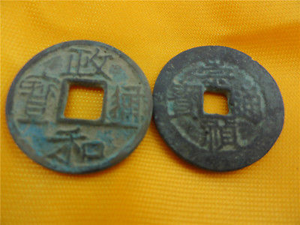

[Oriental Asian China Tools of the trade,the northern song dynasty period,bronze](http://www.ebay.com/itm/141148292074)

Item price

$1.99

Quantity

1

Item number

141148292074

Shipping service

ePacket delivery from China

[Leave feedback](http://feedback.ebay.com/ws/eBayISAPI.dll?LeaveFeedbackShow&useridfrom=802-867&useridto=lengxue&item=141148292074&transactid=0) [Contact seller](http://contact.ebay.com/ws/eBayISAPI.dll?FindAnswers&frm=3998&iid=141148292074&redirect=0&requested=lengxue) [Return item](http://return.ebay.com/ws/eBayISAPI.dll?ResolveReturn&eventName=viewSelectedItem&TransactionId=0&ItemId=141148292074)

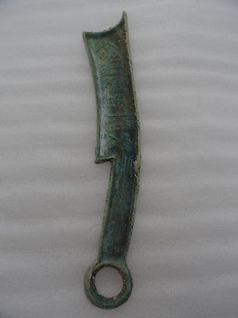

[Archiaze China Tools of the trade,the zhou dynasty,sculpture sword,ancient font](http://www.ebay.com/itm/141149899200)

Item price

$7.99

Quantity

1

Item number

141149899200

Shipping service

ePacket delivery from China

[Leave feedback](http://feedback.ebay.com/ws/eBayISAPI.dll?LeaveFeedbackShow&useridfrom=802-867&useridto=lengxue&item=141149899200&transactid=0) [Contact seller](http://contact.ebay.com/ws/eBayISAPI.dll?FindAnswers&frm=3998&iid=141149899200&redirect=0&requested=lengxue) [Return item](http://return.ebay.com/ws/eBayISAPI.dll?ResolveReturn&eventName=viewSelectedItem&TransactionId=0&ItemId=141149899200)

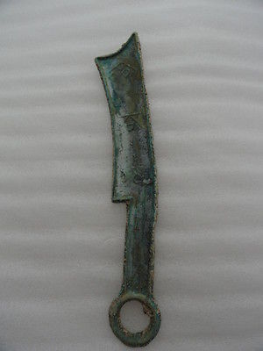

[Archaize China Tools of the trade,the zhou dynasty,sculpture sword,OLD font](http://www.ebay.com/itm/141149901243)

Item price

$6.99

Quantity

1

Item number

141149901243

Shipping service

ePacket delivery from China

[Leave feedback](http://feedback.ebay.com/ws/eBayISAPI.dll?LeaveFeedbackShow&useridfrom=802-867&useridto=lengxue&item=141149901243&transactid=0) [Contact seller](http://contact.ebay.com/ws/eBayISAPI.dll?FindAnswers&frm=3998&iid=141149901243&redirect=0&requested=lengxue) [Return item](http://return.ebay.com/ws/eBayISAPI.dll?ResolveReturn&eventName=viewSelectedItem&TransactionId=0&ItemId=141149901243)

### Order total

Subtotal $110.00

Shipping $39.00

#### Total

## $149.00